

**Excel Assignment - 6**

1. What are the various elements of the Excel interface? Describe how they're used.

Elements of the Excel Interface:

Ribbon: The Ribbon is the horizontal menu at the top of the Excel window. It contains various tabs, each with groups of related commands for tasks like formatting, data manipulation, and more.

Quick Access Toolbar: Located above the Ribbon, it provides easy access to frequently used commands.

Worksheet: Excel's main workspace, consisting of rows and columns where you input and manipulate data.

Cell: Individual units within the worksheet where you can enter data, formulas, or functions.

Formula Bar: Displays the contents of the selected cell and allows you to edit its contents.

Name Box: Displays the cell reference of the currently selected cell.

Column and Row Headers: The letters (columns) and numbers (rows) along the top and left side of the worksheet, respectively, to identify cells.

Tabs: These are at the bottom of the Excel window and represent different worksheets within a workbook.

Scroll Bars: Allow you to navigate large worksheets vertically and horizontally.

Status Bar: At the bottom, it provides information on the current state of the worksheet, such as sum, average, and more.

1. Write down the various applications of Excel in the industry.

Applications of Excel in the Industry:

Data Analysis: Excel is widely used for data analysis, including statistical analysis, financial modeling, and business forecasting.

Financial Management: It's used for budgeting, accounting, financial reporting, and investment analysis.

Project Management: Excel helps in creating Gantt charts, tracking project tasks, and managing timelines.

Inventory Management: Businesses use Excel for inventory tracking and reorder calculations.

Sales and Marketing: Excel aids in managing customer databases, sales tracking, and marketing campaign analysis.

Human Resources: Excel is used for managing employee records, payroll, and recruitment.

Data Visualization: Excel allows for the creation of charts and graphs for visualizing data trends.

Education: Teachers and students use Excel for various educational purposes, such as creating math exercises and data analysis for research.

1. On the ribbon, make a new tab. Add some different groups, insert commands in the groups and name them according to their commands added. Copy and paste the screenshot of the steps you followed.

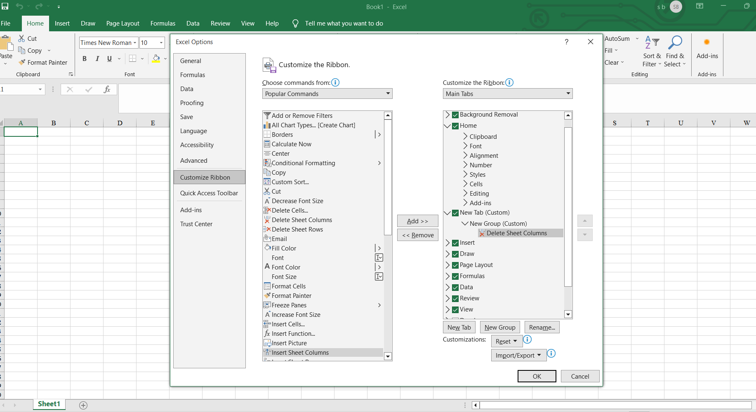

1. Make a list of different shortcut keys that are only connected to formatting with their functions.



5.

What distinguishes Excel from other analytical tools?

6.

Create a table and add a custom header and footer to your table.

Excel Formatting Shortcut Keys:

* Ctrl + B: Bold
* Ctrl + I: Italic
* Ctrl + U: Underline
* Ctrl + 1: Format Cells dialog
* Alt + Enter: Start a new line within a cell
* Ctrl + Shift + L: Add or remove a filter
* Ctrl + Shift + K: Insert a new worksheet
* Ctrl + 5: Strikethrough
* Ctrl + Shift + &: Apply outline border
* Ctrl + 9: Hide rows
* Ctrl + 0: Hide columns
* Ctrl + Space: Select entire column
* Shift + Space: Select entire row



What distinguishes Excel from other analytical tools?

Excel's Distinctive Features:

* **Formula and Function Capability**: Excel offers a wide range of built-in functions and the ability to create custom formulas.
* **Data Analysis Tools**: Excel provides powerful tools for data sorting, filtering, pivot tables, and charts.
* **Accessibility**: It's widely available, user-friendly, and compatible with other Microsoft Office applications.
* **Customization**: You can create custom macros, add-ins, and tailor the interface to your needs.
* **Collaboration**: Excel Online and SharePoint enable real-time collaboration on spreadsheets.
* **Data Visualization**: Excel's charting and graphing options are versatile for visualizing data.
* **Integration**: It can integrate with databases, external data sources, and other analytical tools.

Create a table and add a custom header and footer to your table.

To add a custom header/footer to a table in Excel:

1. Select the "Insert" tab.
2. Click on "Table" to create a table.
3. With the table selected, go to the "Table Design" tab.
4. Click "Header Row" to format the top row as a header.
5. To add a custom header or footer, go to the "Page Layout" tab and click "Header & Footer." You can then enter your custom text and formatting.